LAB ACTIVITY 3(i):

Making Decision In Python

**Learning Outcomes:**

By the end of this laboratory session, you should be able to:

1. Display the use of relational operator in simple program

**Hardware/Software:** Computer, Phyton 3.5 or above.

**Activity 3A**

Activity Outcome**:** Display the use of relational operator in simple program.

(Relational Operator)

Procedure:

**Step 1:** Open Code editor and type the following code:

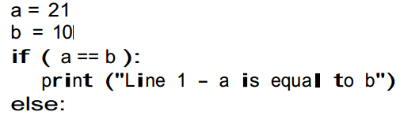 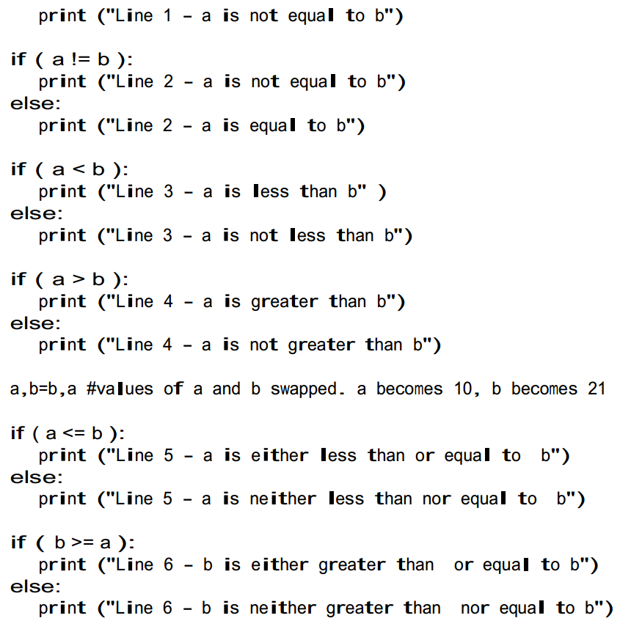

**Step 2:** Save, compile and run the program. Save the program as Act3A.py. Write the output in the area below.

**Output:**

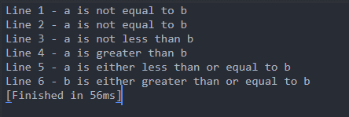

**Activity 3B**

Activity Outcome: Display the use of relational operator in simple program.

(Relational Operator)

Procedure:

**Step 1:** Open code editor and type the following code:

a = 9

b = 4

print(" The Output of 9 > 4 is : ", a > b )

print(" The Output of 9 < 4 is : ", a < b )

print(" The Output of 9 <= 4 is : ", a <= b )

print(" The Output of 9 >= 4 is : ", a >= b )

print(" The Output of 9 Equal to 4 is : ", a == b )

print(" The Output of 9 Not Equal To is : ", a != b )

**Step 2:** Save, compile and run the program. Save the program as Act3B.py. Write the output in the area below.

**Output:**

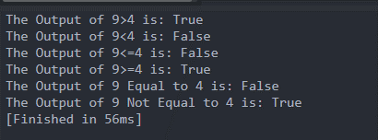

**Activity 3C**

Activity Outcome : Display the use of relational operator in simple program.

(Bitwise Operator)

Procedures:

**Step 1:** Open code editor and type the following code:

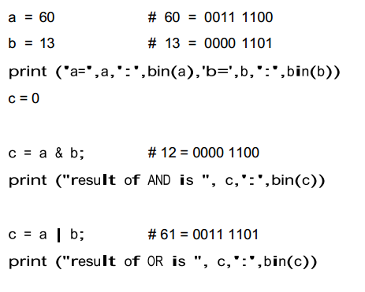

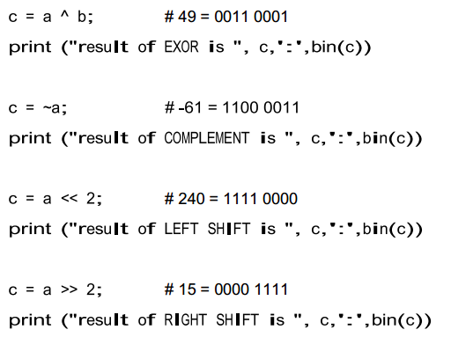

**Step 2:**  Save, compile and run the program. Save the program as Act3C.py. Observe the output.

**Output:**

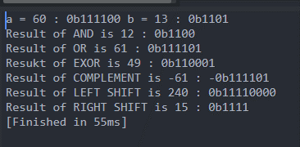

**Activity 3D**

Activity Outcome : Display the use of relational operator in simple program.

(Bitwise Operator)

Procedures:

**Step 1:** Open code editor and type the following code:

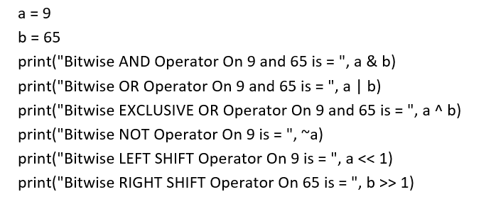

**Step 2:**  Save, compile and run the program. Save the program as Act3D.py. Observe the output.

**Output:**

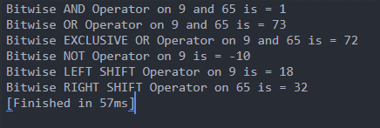

**Activity 3E**

Activity Outcome : Display the use of relational operator in simple program.

(Logical Operator)

Procedures:

**Step 1:** Open code editor and type the following code:

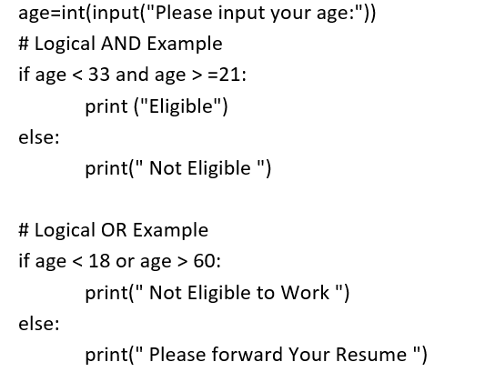

**Step 2:**  Save, compile and run the program. Save the program as Act3E.py. Observe the output.

**Output:**

If Age 30

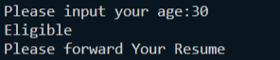

If Age 62

